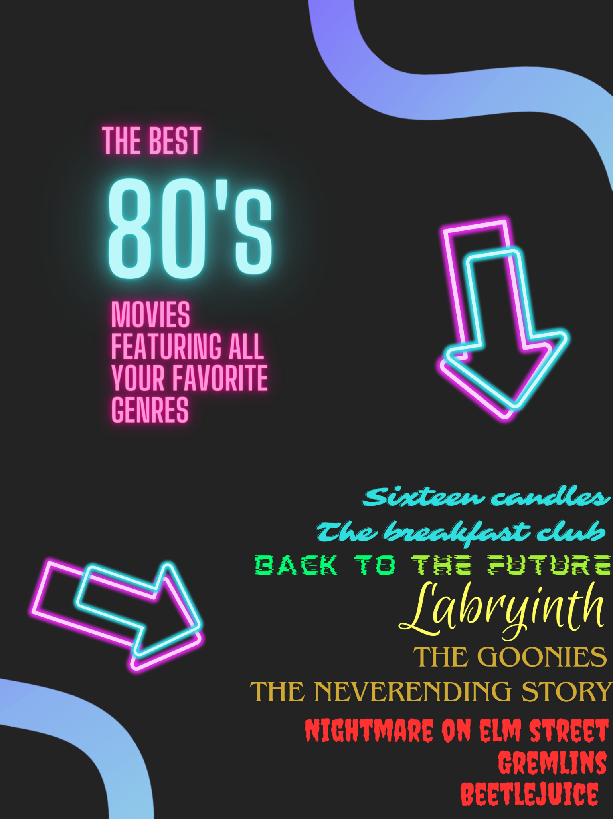 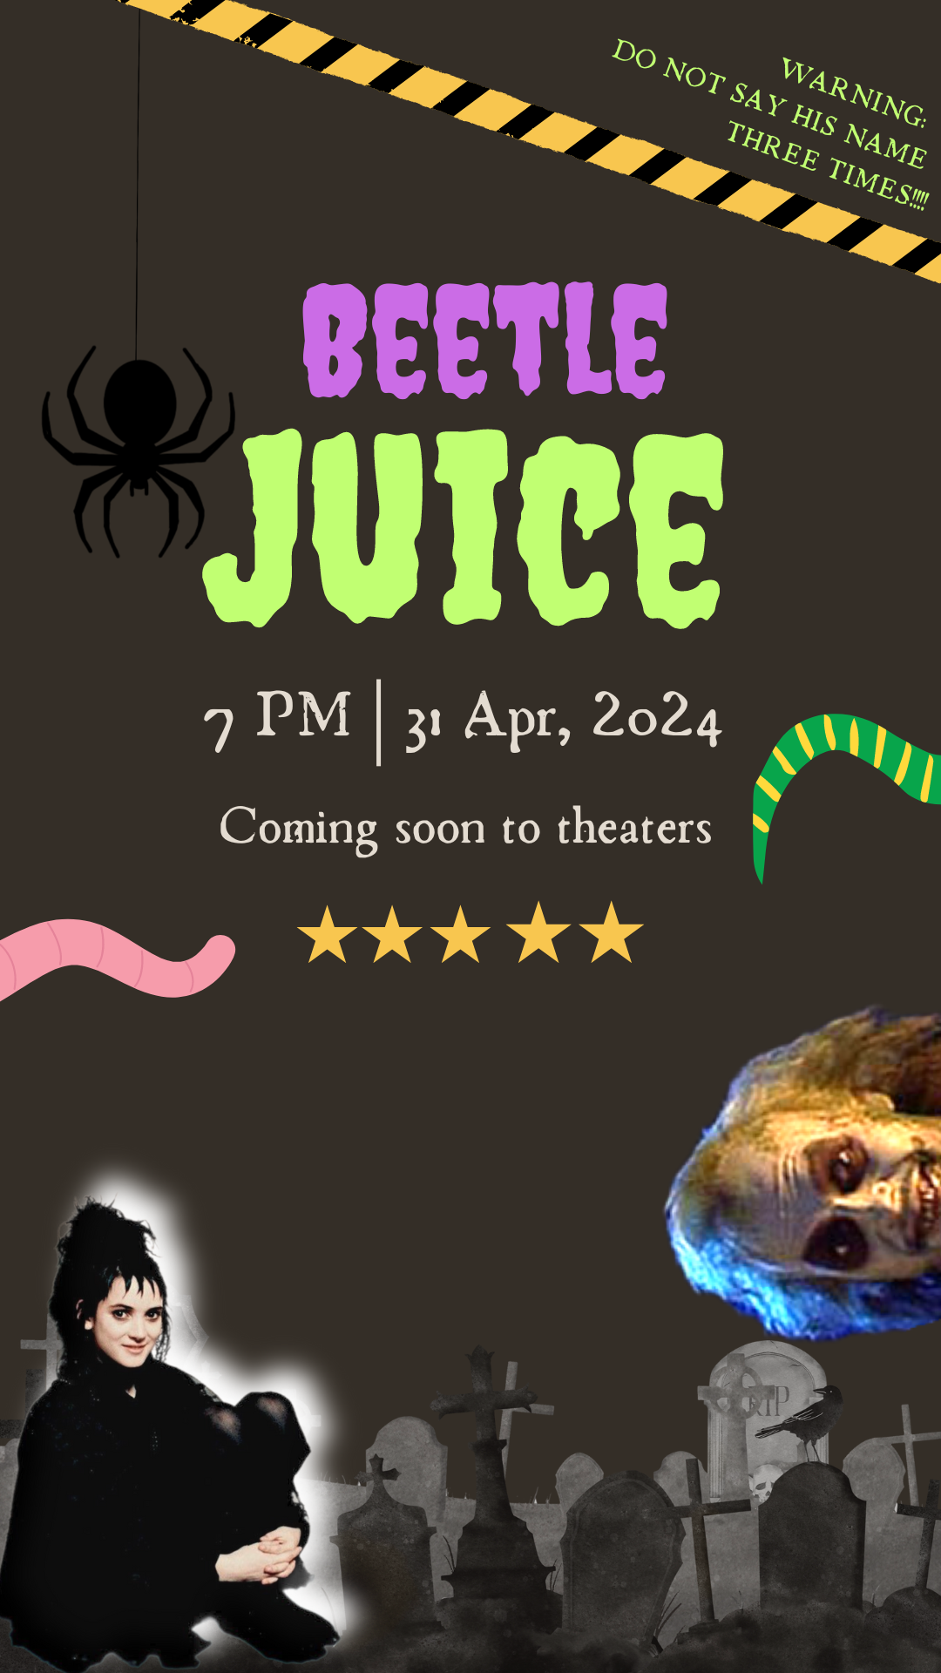

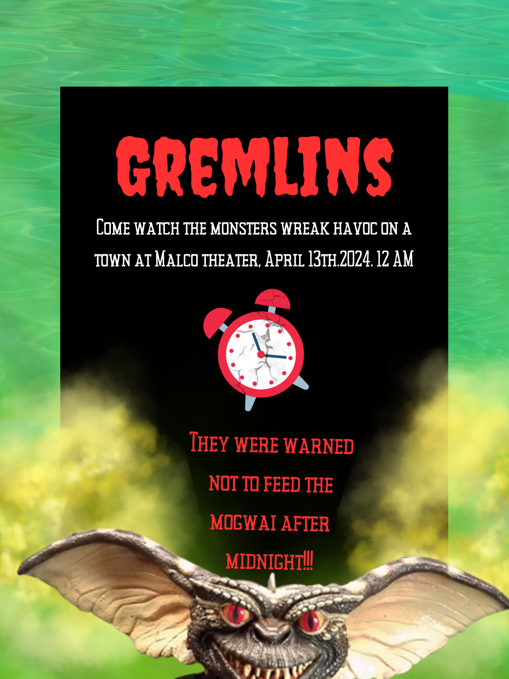 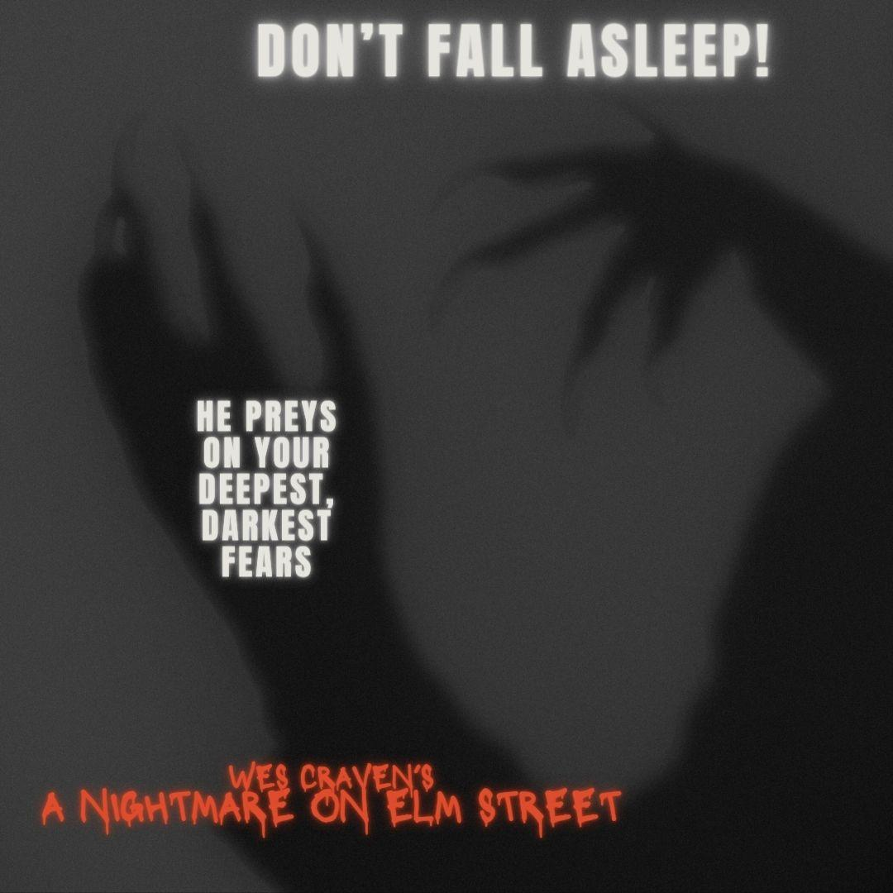

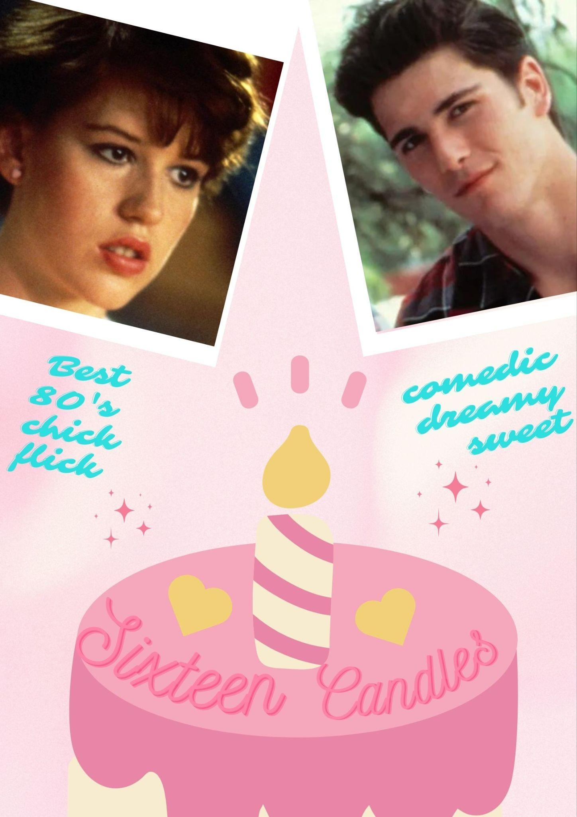 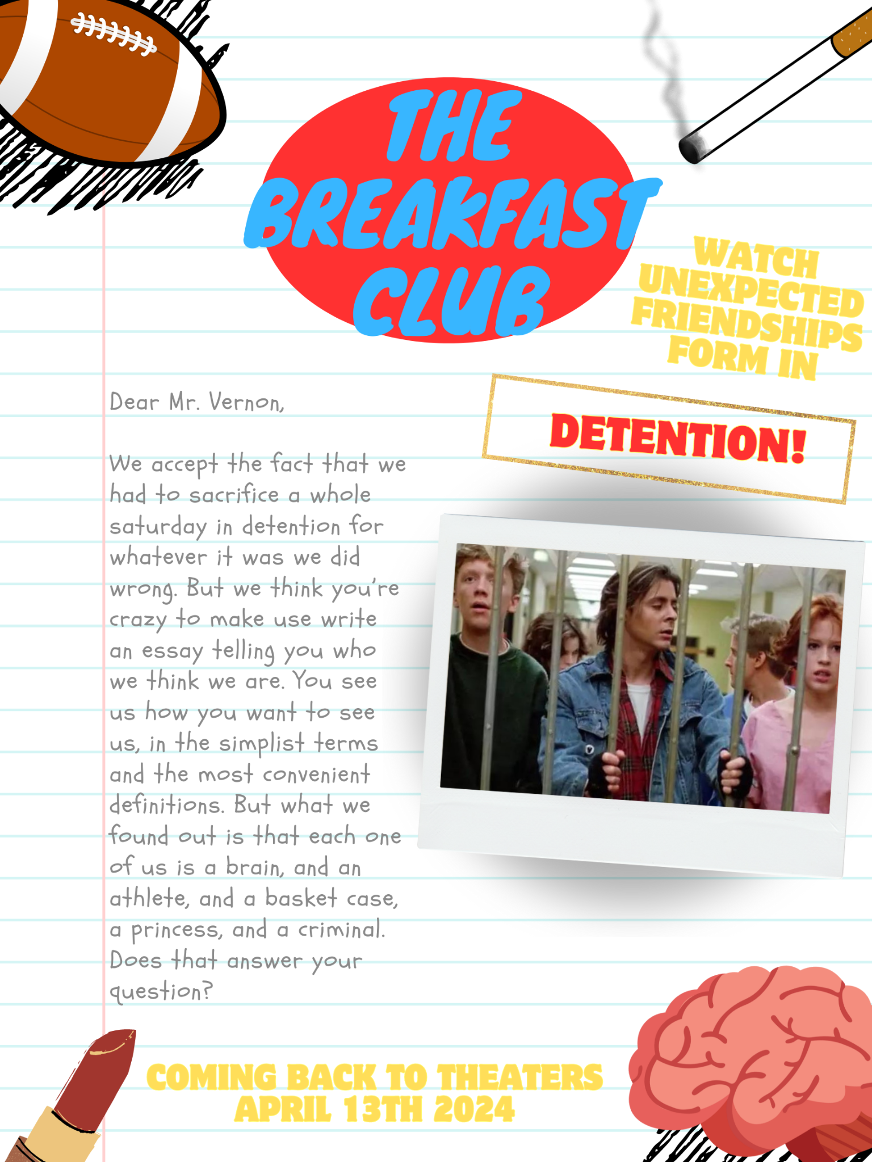

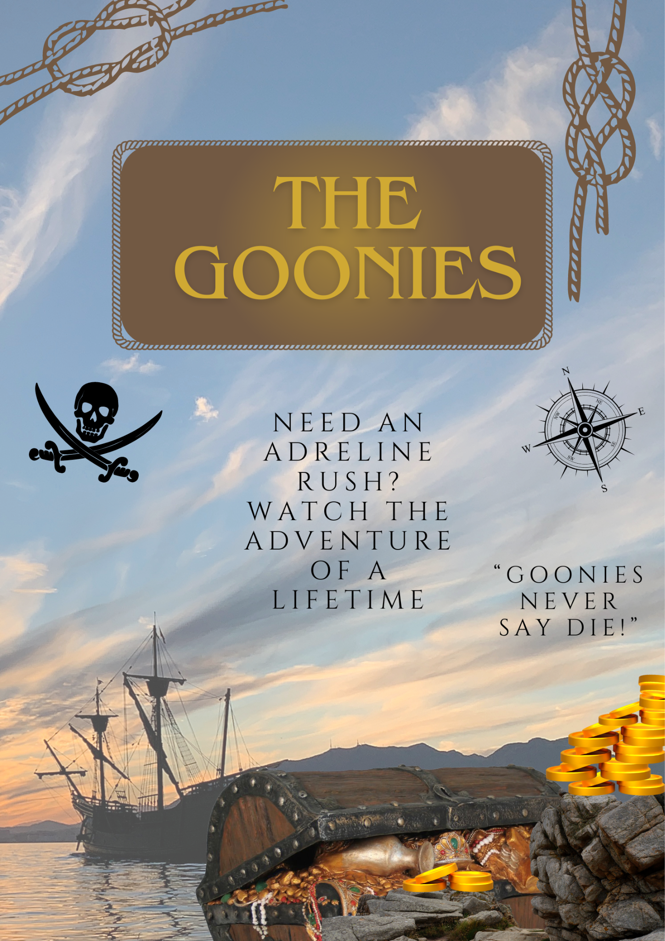 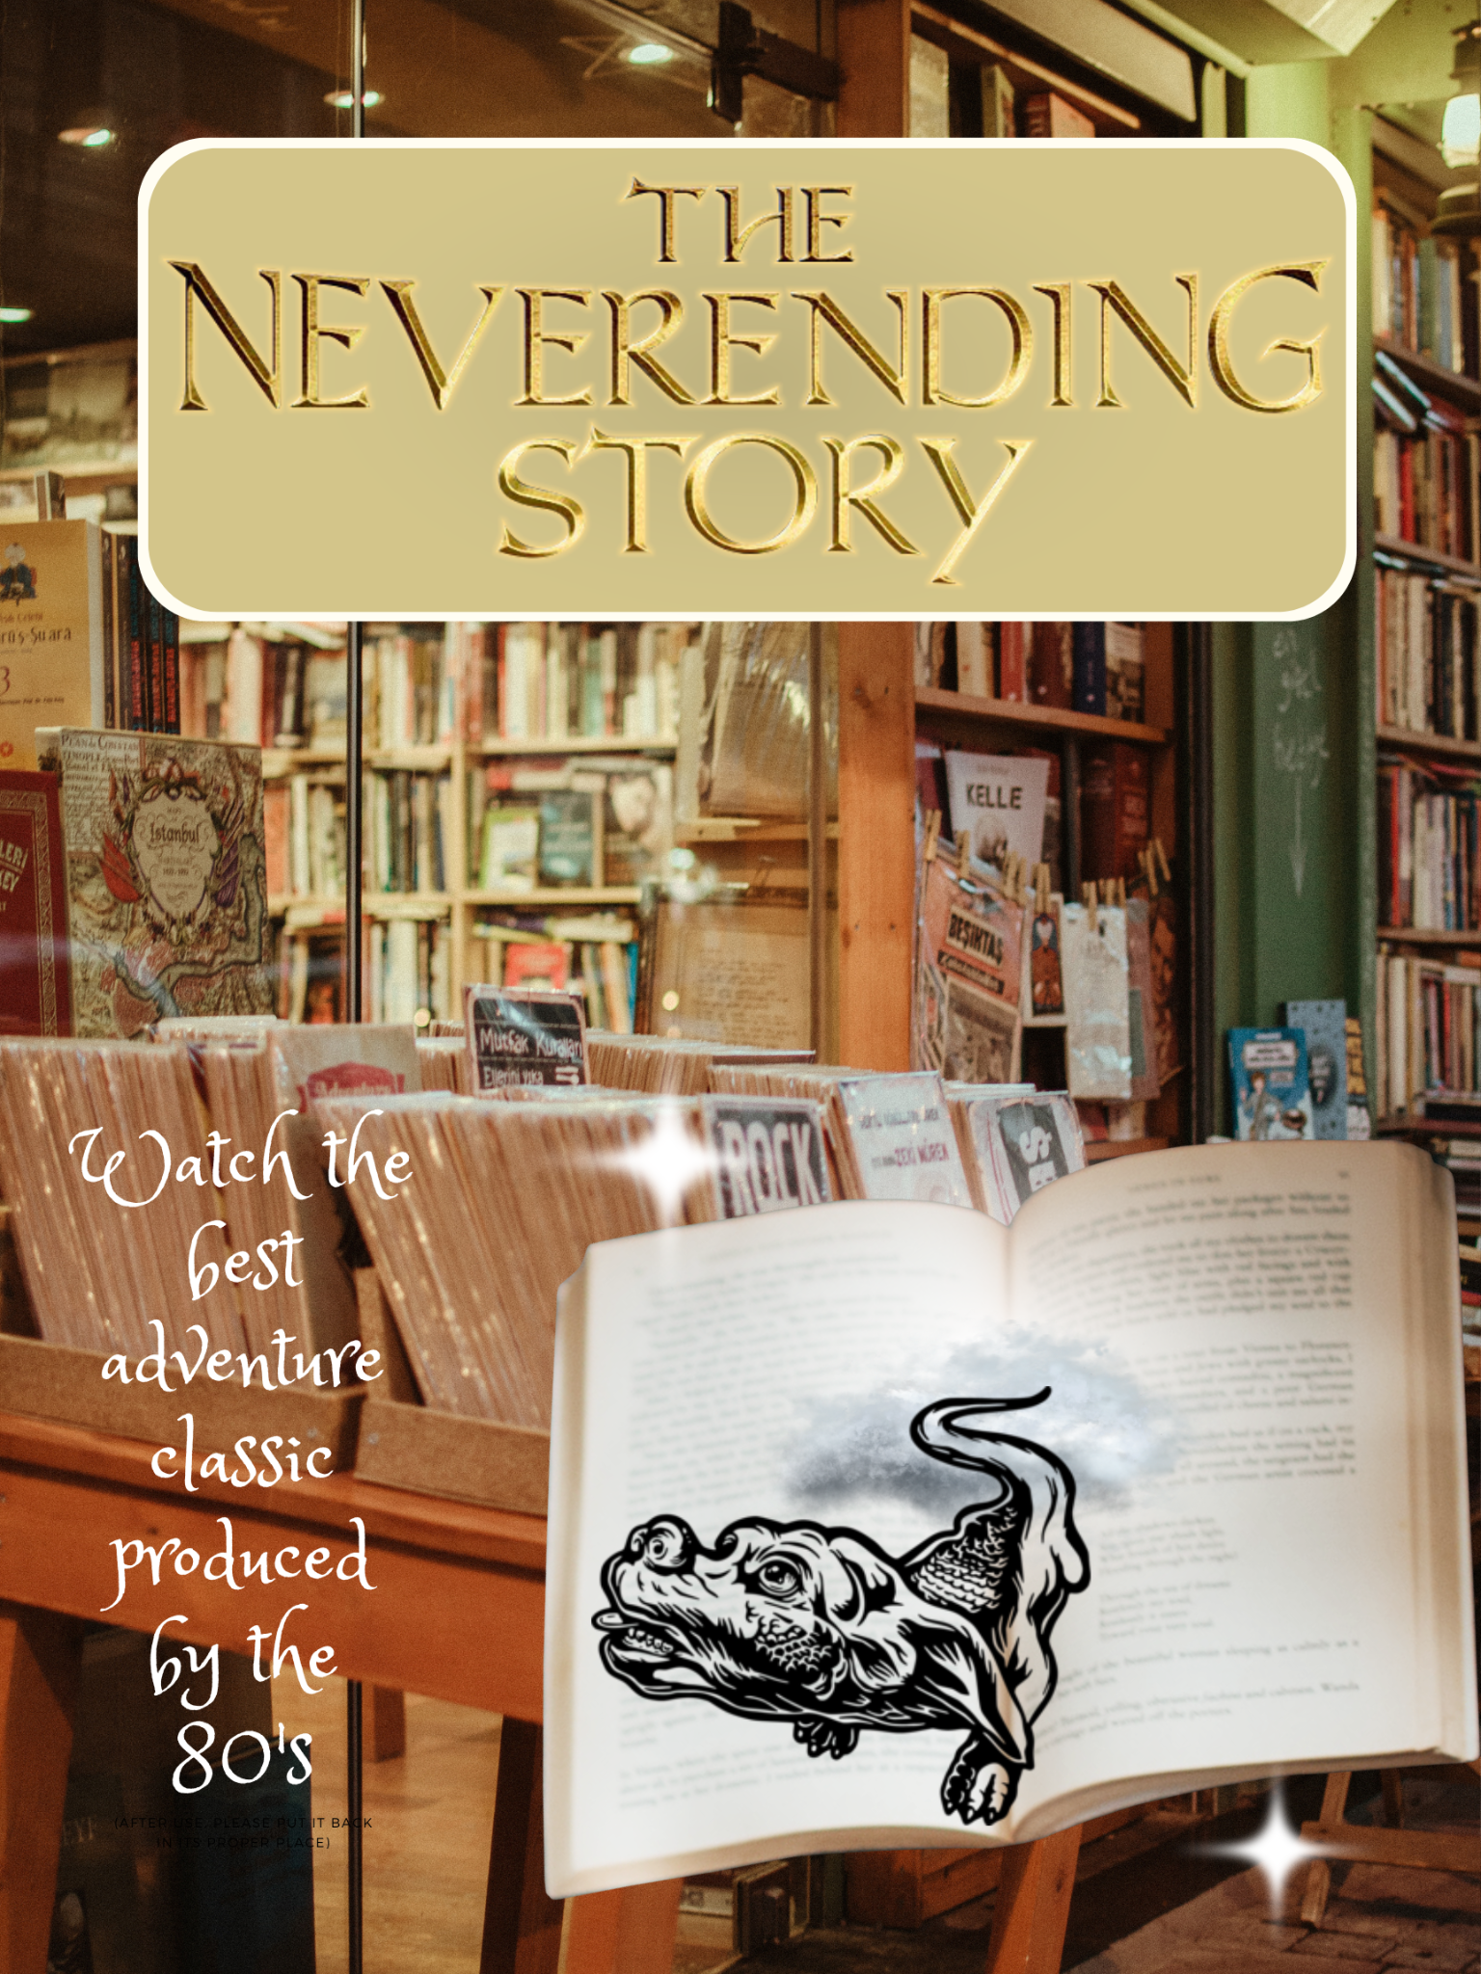

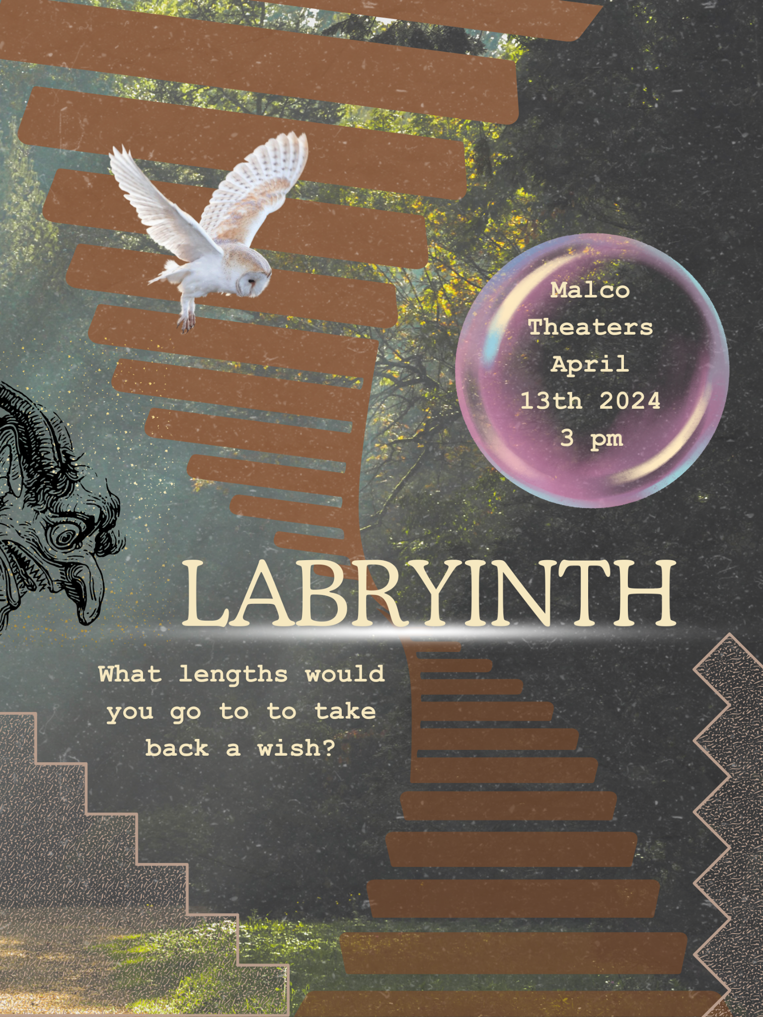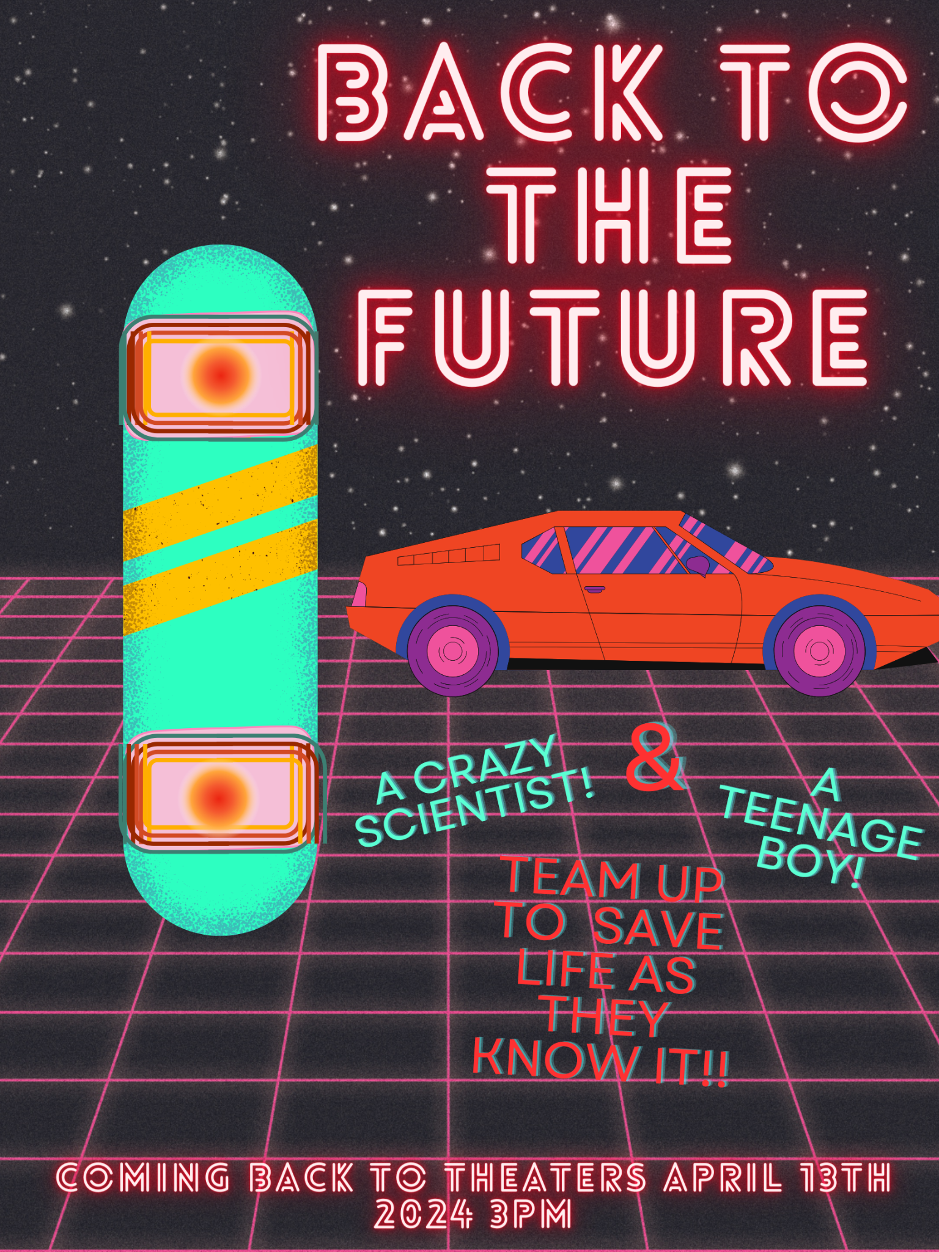

Valencia Vidrine

Professor Alston

Eng. 3604-001

1 April 2024

Explanation:

I chose to do 80’s posters for my digital persuasion. My first poster is an Ad to watch a list of 80’s movies in a neon font because the 80s had a lot of neon colors incorporated into movies, there is a list on the side with different movies, I matched the font to the genres they were so the audience could spot the difference between the movies (RomCom, Futuristic, Fantasy, Adventure, and Horror). For my first poster (Beetlejuice) I chose a cemetery background and a horror font but changed the colors to match the colors featured in the movie. I put worms, snakes, and bugs to give so the audience knows the movie has those gross bugs. I put five stars under the title to imply that it is a top-rated movie and I also selected PNGs from Google of both main characters Beetlejuice himself, and Lydia because I felt like it would give the audience a clearer idea of the horror movie. I thought it would be enticing to also include a warning from the movie. For the Gremlins poster, I used a pool as a back image, I layered green fog on top of it because there is a scene in the movie where the Gremlins multiply in horrific masses by jumping in a pool. I also pulled a png of a gremlin from Google because I liked the idea of a gremlin peeking out. I put a broken clock because the gremlins break their owner’s alarm clock to trick him in the movie. I used a horror font and wrote a message that I would feel would spark interest. I made an Instagram post for Nightmare on Elm Street. I felt that it would be good to have something enticing and simple for the horror movie and the background looks like the character Freddy Kreuger’s hand. For the Sixteen Candles poster, I put a pink background because I felt like the target audience would be teenage girls. I put Polaroid pictures so that I could put the two main love interests pictures (from Google) in them. I incorporated a birthday cake to give a clear main idea to the audience about the plot and put hearts on it to show that the movie features romance. For The Breakfast Club poster, I selected notebook paper (so that I could reference a note written from the movie). I added stickers I felt matched the movie and added a photo that looked like the students were trapped with a detention stamped above it. I feel like this movie poster’s target audience would be kids who might feel like outcasts in their society. For the Goonies poster, I put an old ship in the water as the background because the ending scene in the movie features almost the same thing. I made it more transparent so that the title and stickers I chose would stand out, as well as the treasure chest and coins I added. I wrote my message to appeal to audiences who like adventurous stories as well as a line from the movie. For my NeverEnding story background, I picked out an old bookstore image. I put a book with a character coming out of it to appeal to audiences who desire imaginative stories. For my Labyrinth poster, I put an outdoor background that looked enchanting to appeal to Fantasy lovers. I wanted it to look gritty so I layered on different stickers. It appears chaotic but the movie itself is chaotic with stairs that turn upside down and shift, the movie is full of illusions. There is also a white owl that shows up throughout the movie representing the Goblin King so I included a white owl, I added a bubble as well with a message inside it because the Goblin King uses crystal balls throughout the movie to watch everyone in his kingdom. For my Back to the Future poster I wanted to make it look futuristic so I used a starlit sky with a graph as a background. I put a sporty-looking car and made a hoverboard to showcase elements included in the movie, I used neon colors and a lit-up title to appeal to audiences who enjoy Sci-fi, as well as an enticing message with exclamation points to make it stand out. Overall I feel that as I progressed through each poster I got better at styling them because I picked up new lessons on different things I could do throughout each one and incorporated those useful tricks in the next posters.

Work cited for PNG’s:

“Category: The NeverEnding Story (film).” *Wikimedia Commons*,10 Dec. 2022, 22:59 p.m., <https://commons.wikimedia.org/wiki/Category:The_NeverEnding_Story_%28film%29>, Accessed 3 Apr. 2024

Logotta2. “The NeverEnding Story (1984) Movie Logo PNG Vector.”*seeklogo*, <https://seeklogo.com/vector-logo/463467/the-neverending-story-1984-movie>, Accessed 3 Apr. 2024

Henry, John. “Gremlins-Ninja Cartoon.” *Cleanpng*, <https://www.cleanpng.com/png-gremlin-prop-replica-theatrical-property-puppet-ev-6038804/>, Accessed 3 Apr. 2024

Gothel, Frollo Jakey. “Beetlejuice PNG #4.” *Deviant Art*, 16 Nov. 2021, <https://www.deviantart.com/jakeyfrollogothel/art/Beetlejuice-PNG-4-898117562>, Accessed 3 Apr. 2024

“Winona Ryder Lydia Deetz Beetlejuice movies 1980s” *Shoplook,* <https://shoplook.io/product-preview/winona-ryder-lydia/12502511?from=OutfitItems>, Accessed 3 Apr. 2024

“‘Sixteen Candles’ Turns 30–Whatever Happened to Jake Ryan?!” *toofab,* 4 May 2014, 10:00 A.M., <https://toofab.com/2014/05/04/sixteen-candles-turns-30-whatever-happened-to-jake-ryan/>, Accessed 3 Apr. 2024

Kathiria82. “Samantha.”*fanpop*, <https://www.fanpop.com/clubs/sixteen-candles/images/55760/title/samantha-photo>, Accessed 3 Apr. 2024

Singh, Olivia. “THEN AND NOW: The cast of ‘The Breakfast Club’ 35 years later.” *Business Insider,* 16 Feb. 2020, 1:10 P.M., <https://www.businessinsider.com/the-breakfast-club-cast-where-are-they-now-photos-2019-2>, Accessed 3 Apr. 2024

Creative Commons 4.0 BY-NC “Treasure Chest PNG Free Image.” *PNG All,* 2 June 2019, 2:57 P.M., [*https://www.pngall.com/treasure-chest-png/download/31792*](https://www.pngall.com/treasure-chest-png/download/31792)*,* Accessed 3 Apr. 2024